LAB # 01
Objective
Introduction to Visual Studio.Net
Visual Studio .NET Integrated Development Environment (IDE)

Introduction to Visual Studio.Net
- Developed at Microsoft by a team led by Anders Hejlsberg and Scott Wiltamuth .
- Based from C, C++ and Java.
Incorporated into .NET platform.
Visual Studio .NET Integrated Development Environment (IDE)
The Visual Studio product family shares a single integrated development environment (IDE) that is composed of several elements: the Menu bar, Standard toolbar, various tool windows docked or auto-hidden on the left, bottom, and right sides, as well as the editor space. The tool windows, menus, and toolbars available depend on the type of project or file you are working in.

Below we see the Visual Studio IDE (Integrated Development Environment):
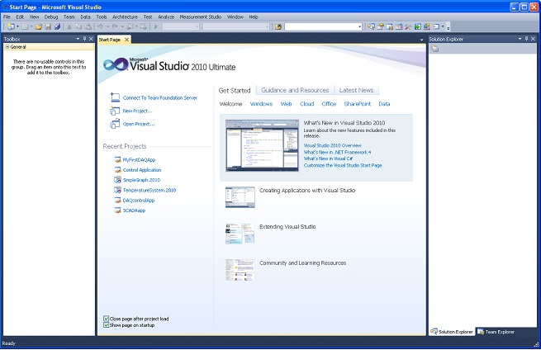

Visual Studio .NET (IDE) Overview
The first thing you do when you want to create a new application is to create a new project.
This can be done from the Start Page

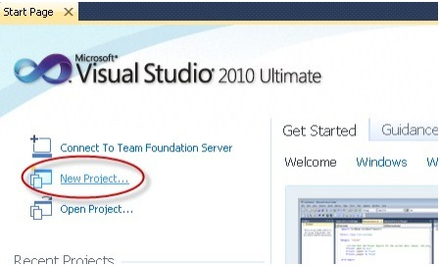
Then the “New Project” window appears:
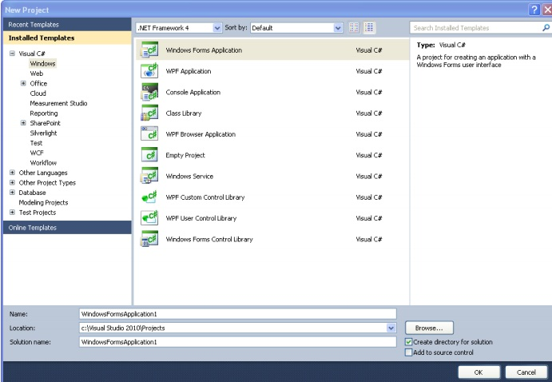
In this window you will select an appropriate template based on what kind of application you want to create, and a name and location for your project and solution.
The most common applications are:
- Windows Form Application
- Console Application
- WPF Application
- ASP.NET Web Application
- Silver light Application
Solution Explorer
Solutions and projects contain items that represent the references, data connections, folders, and
Files that you need to create your application. A solution container can contain multiple projects and
a project container typically contains multiple items.

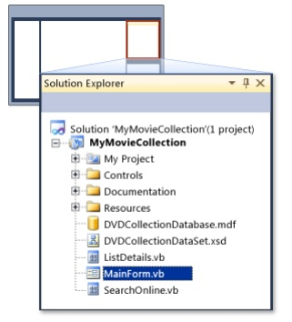

Toolbox
The Toolbox contains all the controls, etc. we can use in our user interface. In order to use them in our user interface, we just drag and drop them to the “Form”, as shown below:

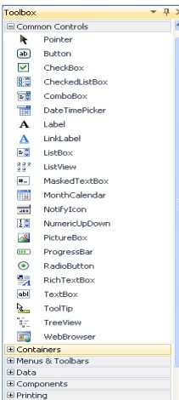

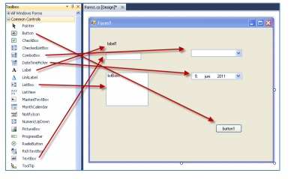

Programming with .NET Framework
.NET framework is a programming platform developed by Microsoft. C# was specifically written as a language that will use the .NET Framework. The framework is made up of two different things:
- A huge library of code that we can call from our C# programs. This saves us writing everything ourselves.
- A “runtime” module, which runs our programs for us when we’re ready (this happens invisibly - you don't need to worry about it)
When you write a C# program (or a program in any of the other .NET languages), you typically call some code that lives in the library, as well as writing some of your own code.
There are so many classes in the .NET framework, and some of them are pretty complicated, so we certainly won't try to cover the whole thing here.

A Simple C# Program
This lab will touch on many topics with only a minimum of explanation. Let’s start by looking at a simple C# program. The complete program source is shown in the top shaded area in FigureAs shown, the code is contained in a text file called SimpleProgram.cs.
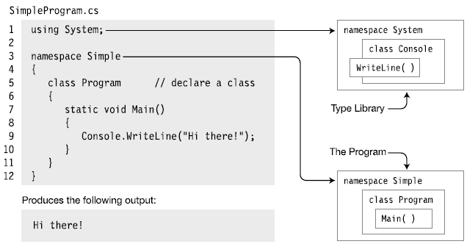

Line Number Description
Line 1 Tells the compiler that this program uses types from the System namespace.
Line 3 Declares a new namespace, called Simple.
• The new namespace starts at the open curly brace on line 4 and extends through the matching curly brace on line 12.
• Any types declared within this section are members of the namespace.
Line 5 Declares a new class type, called Program.
• Any members declared between the matching curly braces on lines 6 and 11 are
Members that make up this class.
Line 7 Declares a method called Main as a member of class Program.
• In this program, Main is the only member of the Program class.
• Main is a special function used by the compiler as the starting point of the program.
Line 9 Contains only a single, simple statement; this line constitutes the body of Main.
• Simple statements are terminated by a semicolon.
• This statement uses a class called Console, in namespace System, to print out the message to a window on the screen.
• Without the using statement in line 1, the compiler wouldn’t have known where to look for class Console.
Note: Identifiers are case sensitive. For instance, the variable names myVar and MyVar are different identifiers.

Main: The Starting Point of a Program
Every C# program must have one class with a method (function) called Main. In the SimpleProgram program shown previously, it was declared in a class called Program.

• The starting point of execution of every C# program is at the first instruction in Main.
• The name Main must be capitalized.

Simple Statements
A statement is a source code instruction describing a type or telling the program to perform an action.
A simple statement is terminated by a semicolon.

Blocks
A block is a sequence of zero or more statements enclosed by a matching set of curly braces; it acts as a single syntactic statement

Text Output from a Program
A console window is a simple command prompt window that allows a program to display text
and receive input from the keyboard. The BCL supplies a class called Console (in the System
namespace), which contains methods for inputting and outputting data to a console window.

Write
Write is a member of the Console class. It sends a text string to the program’s console window.
In its simplest form, Write sends a literal string of text to the window. The string must be enclosed in quotation marks. The following line of code shows an example of using the Write member:
This code produces the following output in the console window:

Console.Write("This is trivial text.");
↑
Output string
This is trivial text.
Another example is the following code, which sends three literal strings to the program’s console window:

System.Console.Write ("This is text1.");
System.Console.Write ("This is text2.");
System.Console.Write ("This is text3.");

This code produces the output that follows. Notice that Write does not append a newline character after the string, so the output of the three statements runs together on a single line.
This is text1. This is text2. This is text3.
↑ ↑ ↑
First Second Third
statement statement statement

WriteLine
WriteLine is another member of Console, which performs the same functions as Write, but appends a newline character to the end of each output string. For example, if you use the preceding code, substituting WriteLine for Write, the output is on separate lines:

System.Console.Write ("This is text1.");
System.Console.Write ("This is text2.");
System.Console.Write ("This is text3.");

This code produces the following output in the console window:
This is text 1.
This is text 2.
This is text 3.

Console.ReadLine()
Used to get a value from the user input.

Int32.Parse()
Used to convert a string argument to an integer.
Allows math to be preformed once the string is converted.

Data Types And Variables
Variables” are simply storage locations for data. You can place data into them and retrieve their
Contents as part of a C# expression. The interpretation of the data in a variable is controlled through
“Types”.
The C# simple types consist of:
- Boolean type
- Numeric types: Integrals, Floating Point, Decimal
- String type
Arithmetic Operators.
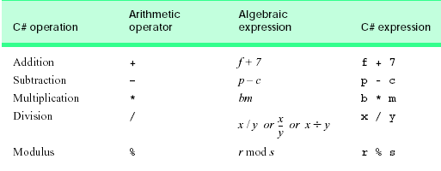

Escape Sequences.
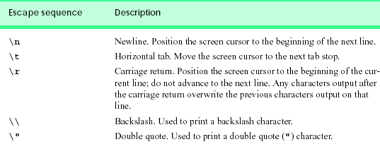

Tasks
Q # 01 (a) Write the output of the program

using System;
class Addition
{
static void Main( string[] args )
{
string firstNumber, secondNumber;
int number1, number2, sum;
Console.Write( "Please enter the first integer: " );
firstNumber = Console.ReadLine();
Console.Write( "\nPlease enter the second integer: " );
secondNumber = Console.ReadLine();
number1 = Int32.Parse( firstNumber );
number2 = Int32.Parse( secondNumber );
sum = number1 + number2;
Console.WriteLine( "\nThe sum is {0}.", sum );
}
(b)Output of Block A and Block B are same if it is true then write your findings
Block A
int number1;
Console.Write( "Please enter the first integer: " );
number1 = Int32.Parse( Console.ReadLine() );
Console.WriteLine( "\nThe sum is {0}.", number1);

Block B
Console.Write( "\nPlease enter the second integer: " );
secondNumber = Console.ReadLine();
number1 = Int32.Parse( firstNumber );
Console.WriteLine( "\nThe sum is {0}.", number1);

Q # 02 Write an application that asks the user to enter two numbers, obtains the two numbers from the user and prints the sum, product, difference and quotient of the two numbers.

Q # 03 Write an application that inputs from the user the radius of a circle and prints the circle’s diameter, circumference and area. Use the following formulas (r is the radius): diameter = 2r, circumference = 2 ðr, area = ðr2.

